Genie Spaces
Genie Spaces take the opposite approach. Instead of pre-building answers, a Genie Space lets business users ask their own questions in plain English. The Space interprets the question, generates SQL, runs it against your Unity Catalog tables, and returns the result.
All without the user needing to know SQL.

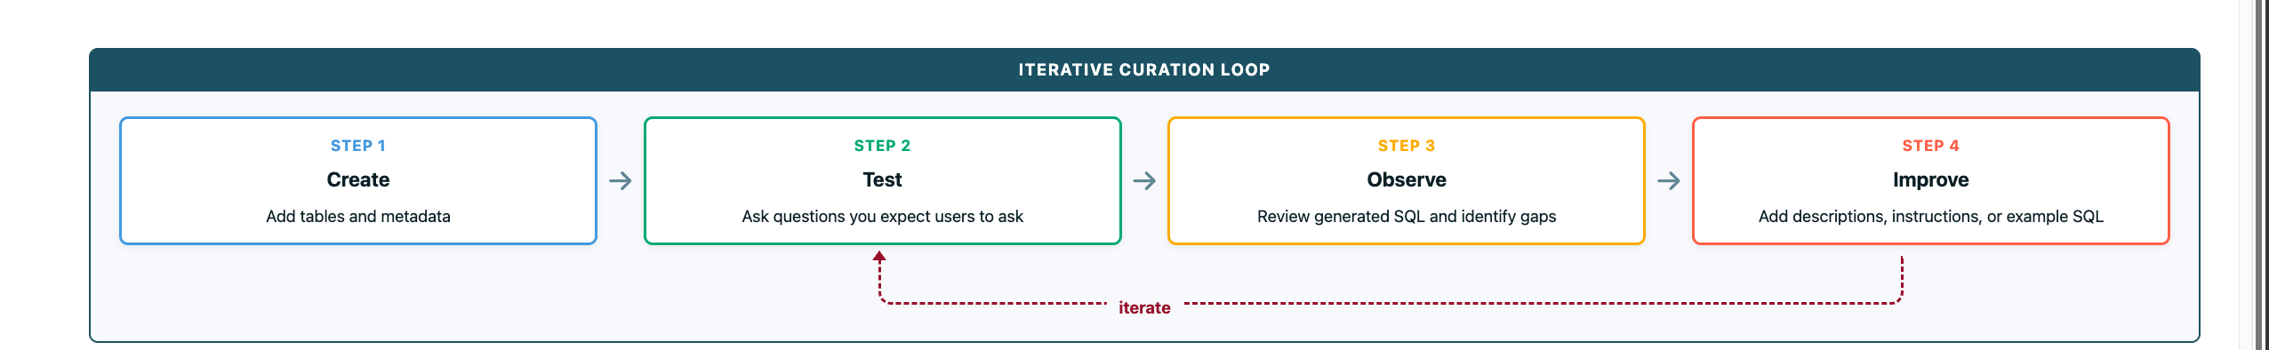
Key idea: The loop never really ends. Every real user question is a chance to improve the Space, and small, frequent passes beat large rewrites.
order matters. Each layer builds on the previous one.

1. Define Purpose and Scope
Start by deciding what the Genie Space is for.
- Define the audience and business topic
- Identify the key questions the space should answer
- Keep the scope narrow and focused
A Genie Space should support a specific use case, not every possible question across the business.

2. Add Focused Unity Catalog Tables and Relationships
Once the purpose is clear, select the data that supports it.
- Use a small, focused set of Unity Catalog tables or views
- Ensure relationships (joins) are defined (PK/FK, views, or Knowledge Store)
- Prefer well-documented, analytics-ready tables
- Aim for about 5 tables or fewer when possible
- Pre-join or simplify data with views or metric views if needed
Without clean data and clear relationships, the rest of the curation work is much harder.

3. Add Metadata and Prompt Matching
Metadata is the strongest early accuracy lever and often the easiest win.
- Add descriptions and synonyms to clarify what columns mean
- Resolve ambiguity across similar fields
- Help Genie select the right columns when questions are vague
Also enable prompt matching:
- Format assistance helps Genie understand data formats and value patterns
- Entity matching maps user language, including misspellings, to real data values
Many spaces improve significantly at this stage before any SQL is added.

4. Add SQL Expressions
SQL expressions define your reusable business logic.
- Define metrics and KPIs
- Create reusable filters and dimensions
- Standardize how business terms are calculated
Recommended to use SQL expressions for common, reusable definitions instead of text.

5. Add Example SQL Queries
Example SQL queries teach Genie how to answer common or complex questions.
- Pair natural language questions with verified SQL
- Use them for multi-step logic or ambiguous prompts
- Parameterized examples can be reused as patterns
Genie can use these examples directly or learn from them to answer similar questions.

6. Add General Instructions
Use text instructions only when something cannot be expressed in SQL or metadata.
Good use cases include:
- Clarification rules
- Formatting and output behavior
- Language or response preferences

Avoid using instructions to define metrics, joins, or logic.
Why Table Quality Matters
No amount of instructions can compensate for poorly structured input data. If your column names are cryptic, your data is inconsistent, or your tables require complex transformations to be useful, Genie will struggle regardless of how much guidance you provide.

Best Practices
- Use gold tables - curated, analytics-ready tables that represent the final layer of your data pipeline. This is what we did in the previous demo with the _gold suffix tables.
- Keep tables focused - A space with 5 well-chosen tables will outperform a space with 20 loosely related ones. The more tables you add, the more likely Genie is to pick the wrong one.
- Define relationships - If foreign key relationships are defined in Unity Catalog, Genie can use them to determine how tables join together. If they are not defined, document the relationships in instructions.
- Clear column names - If a column is named size, that is ambiguous. A column named franchise_size_category is self-documenting. When you cannot rename columns, add descriptions instead.
- Don't auto-generate descriptions - AI-generated column comments can be generic or misleading. Only add descriptions that provide context Genie would not otherwise have.

When to Use Views
If your data model is complex with many self-joins, complicated aggregations, or columns that need transformation consider creating a view that simplifies the data for Genie.
A pre-joined, pre-aggregated view can dramatically reduce the complexity of the SQL Genie needs to generate.

Where to Invest Time for the Biggest Impact
When building a Genie space, not all effort produces equal results.
Some improvements significantly increase accuracy and usability, while others add complexity without much benefit.
Focus your time on the areas that have the largest impact on how Genie understands and answers questions.

High-Impact Levers
These are the areas where your effort will most improve Genie performance:
- Start with clear business questions and a focused scope - Define the key questions you want Genie to answer. Avoid trying to support everything at once.
- Well-described tables and columns using business language - Add clear, human-readable descriptions. Genie relies heavily on this context to interpret user questions correctly.
- Example SQL aligned to real usage patterns - Provide sample queries that reflect how users actually ask questions. These act as patterns Genie can learn from.
- Simple, consistent joins with a clear row-level meaning - Make relationships between tables easy to follow, and ensure each table clearly represents one type of record. Avoid joins that unintentionally duplicate or distort results.

Low-Impact (Common Traps)
These are common areas where effort often does not translate into better outcomes:
- Overly long or complex instructions - More text does not mean better results. Keep instructions concise and focused.
- Adding too many tables upfront - A large, unfocused dataset makes it harder for Genie to choose the right data.
- Over-optimizing edge cases early - Focus on the most common and important questions first. Handle edge cases later.
- Treating Genie as 'set and forget' - Genie improves through iteration. Regularly review results and refine your setup.

